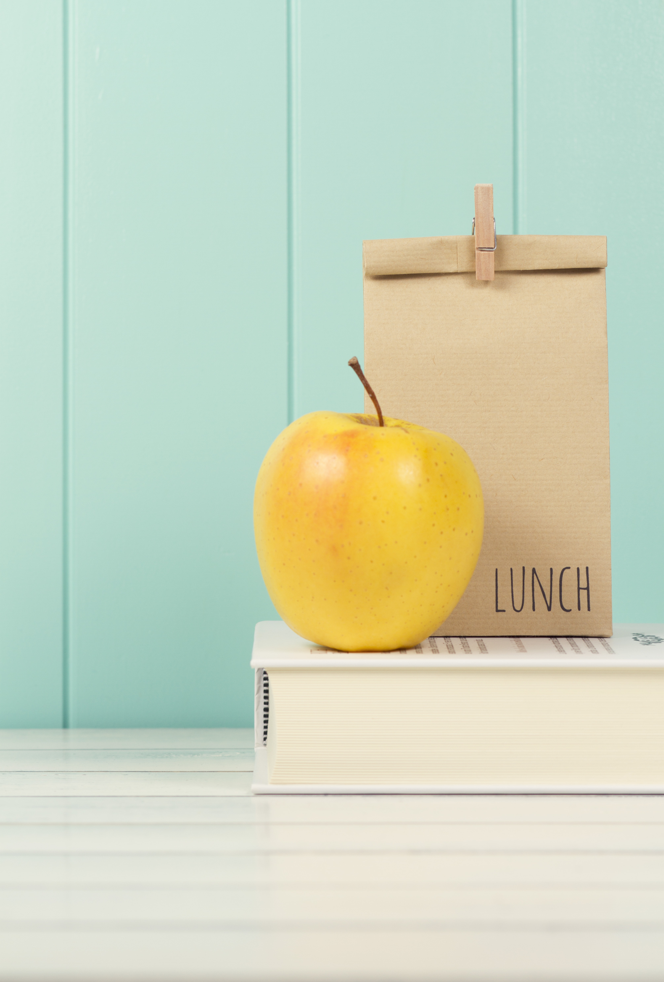
with Graphic Design by Sarah Koontz
Let’s Brown Bag It…
{A Real Mom’s Guide to Packing
Healthful School Lunches}
Including:
- 50 + Ingredient Ideas
- Supply Checklist
- Shopping List
- 5 Sample
Lunches
And More…
By: Sammi Ricke

Sammi Ricke
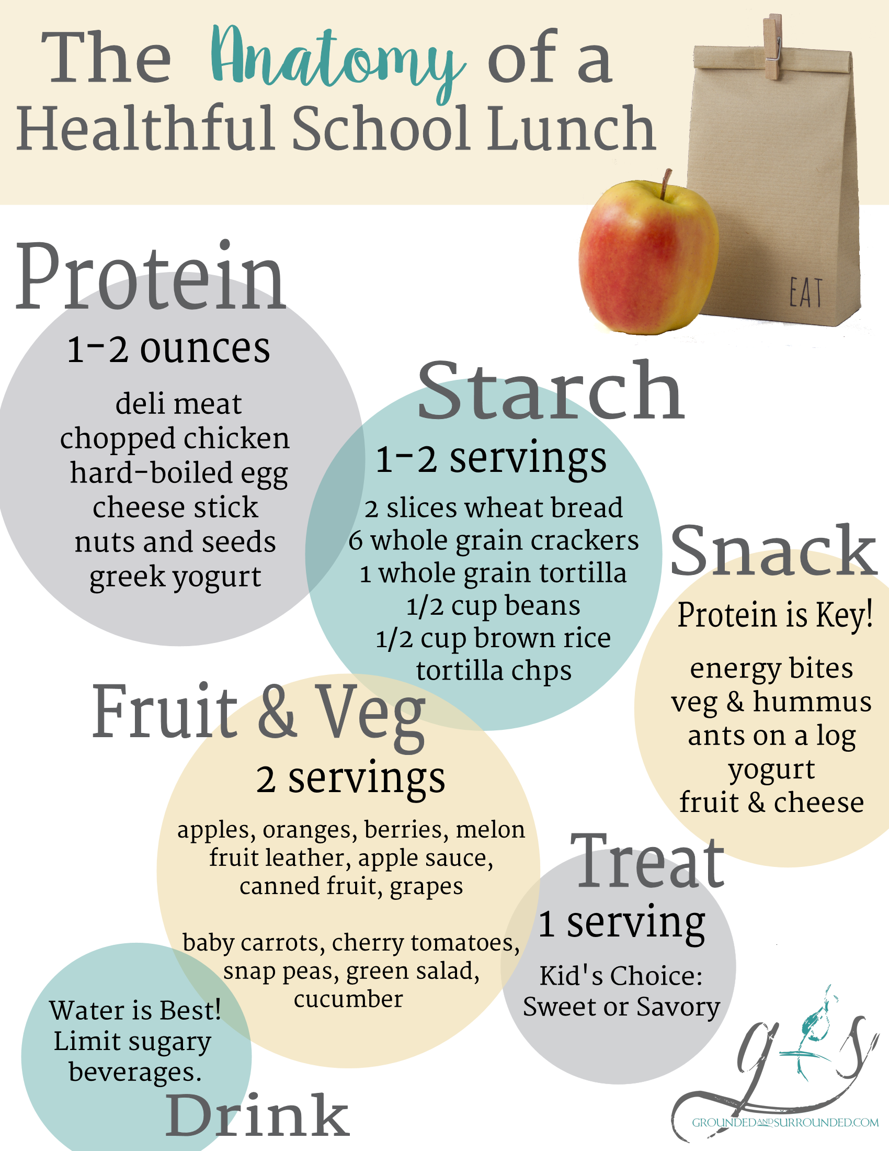
Real Mom’s Sample Lunch Ideas
Real Mom’s Brown Bag Shopping List

Here are some real examples of lunches I pack for my kids each week.

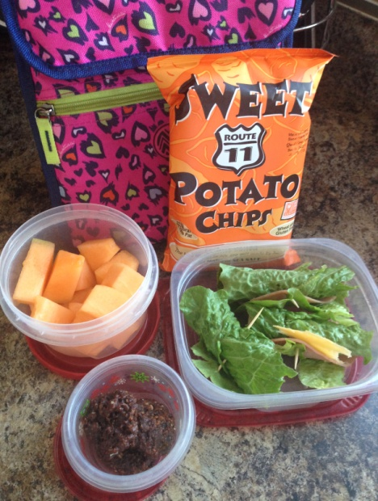
Lunch #1
- Romaine Lettuce wrapped around sliced ham and shredded cheese secured with a toothpick.
- Sliced Melon
- Sweet Potato Chips
- Homemade Muffin

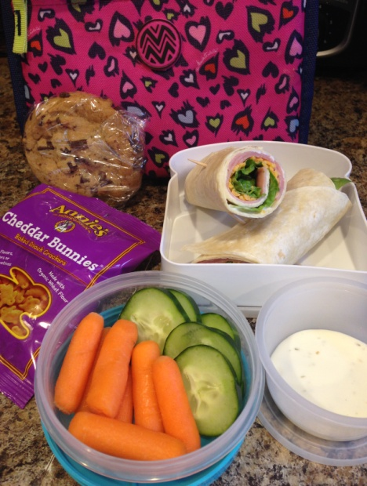
Lunch #2
- Tortilla with Shredded Cheese, Ham & Lettuce
- Carrots and Cucumbers with Ranch dip
- Annies Cheddard Bunnies
- Homemade Cookie

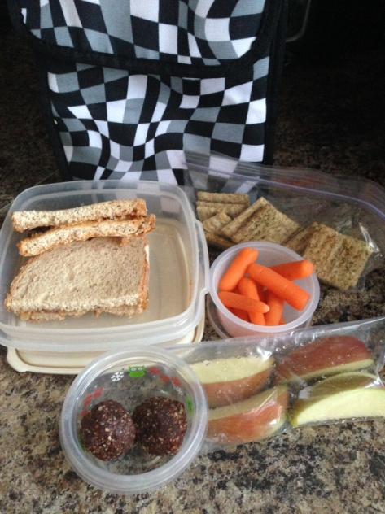
Lunch #3
- Peanut Butter & Honey on Whole Wheat Bread
- Apple Slices
- Whole Grain Crackers
- Energy Bites
- Carrot Sticks

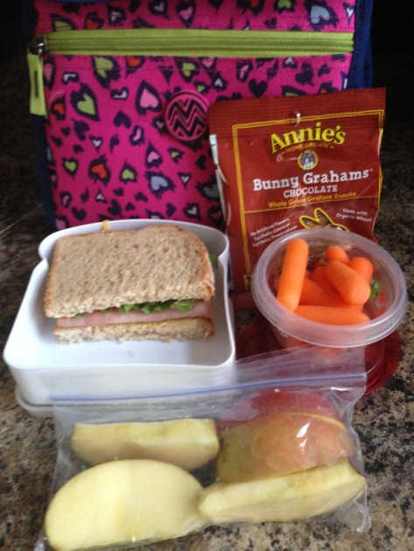
Lunch #4
- ½ sandwich on whole wheat with lettuce, ham and mayo
- Sliced Apples
- Carrot Sticks
- Annie’s Bunny Grahams

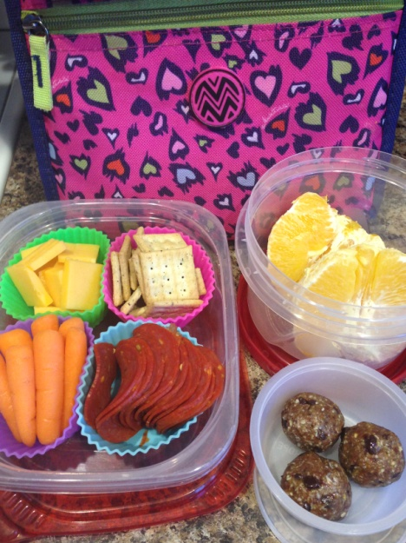
Lunch #5
- Turkey Pepperoni, Cheese Slices
- Crackers
- Carrot Sticks
- Homemade Energy Bites
- Orange

Real Mom’s Brown Bag Shopping List
Protien/Starch Combos
- Lunch Meat and Sliced Cheese Roll ups
- Sandwich made with whole grain bread, deli meat, cheese
- Romaine Lettuce Wraps with lunch meat and shredded cheese
- Turkey Pepperoni and a Cheese Stick or Cheese Cubes
- Tortilla filled with cheese and refried beans with a side of salsa
- Soup in a Thermos
- Hard Boiled Egg + Peanut Butter Cracker Sandwich
- Raw Nuts with String Cheese
- Hummus with Veggies

- Plain Greek Yogurt topped with raw local honey and a side of granola
- Nut Butter Sandwich
- Nut Butter with Apples or Veggies

- Jerky and Crackers

Snacks
- Energy Bite (larabar or homemade)
- Homemade Muffin
- Cheese Stick
- Granola Bars
- Granola and Yogurt
- Crackers and Cheese
- Ants on a Log
Vegetables
- Baby carrots
- Sliced cucumbers
- Sugar snap peas
- Cherry tomatoes
- Small green salad with dressing
- Sliced Bell peppers
- Vegetable Soup
- Snap Pea Crisps
- Sweet Potato Chips
- Pickles

Fruit
- Apple slices
- Orange slices
- Little Cuties (Halos)
- Strawberries (halved)
- Blueberries
- Blackberries
- Melon balls
- Raspberries
- Applesauce
- Grapes, sliced
- Fruit leather
- Banana
- Peaches
- Fruit Salad
- Homemade Fruit Snacks

Supplies
- Lunch Box/Bag
- Divided BPA free containers
- Small plastic containers
- Silicone Muffin Cups
- Fruit Puree Pouches
- Reusable snack bags
- Reusable Utensils
- Ice Packs
- Disposable snack and sandwich bags

